# Command line cheat sheet



# Lab Part 1 – Getting Started with Kali Linux:

**Create a directory for this course with the following name: SkillsDevelopment1, then a sub-directory for lab two with the following name: Lab2**

**3. Now, change directory into the newly created directory.**

4**. Create a python file with the following name myfile.**

**5. To make sure the python file is successfully created, list all the files in the current directory Take a screenshot of the command used to accomplish the task & output**

**6. Now, rename the python file to HelloWorld.py**

**Using nano editor; create an empty python file, Implement a simple python program that given a number x prints a pyramid with same number of levels**.

**8. Run your python code using the command line**

# Lab Part 2 - What is the Command?

**1. What is the command used to copy files ?**

cp {filepath} {destination path}

**2. What is the command used to delete files and directories?**

rm {filepath}

**3. What is the command used to rename files?**

mv {filename} {new**_**filename}

**4. What is the command used to display the contents of a file?**

cat {filepath}

**5. What is the command used to clear the terminal if it gets filled up with too many commands?**

clear

# Lab Part 3 – Generate a Gif from still images using the command line:

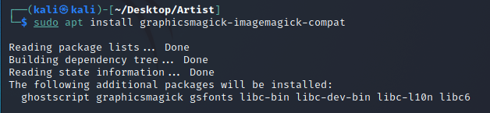

**Installing ‘graphicsmagick-imagemagick-compat’ package**

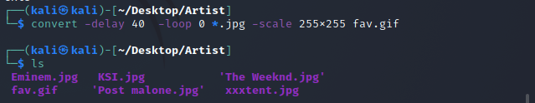

**Creating GIF**

# Lab Part 4 – Install fortune:

**Generating a random fortune**

Lab Part 5 – Install GIMP:

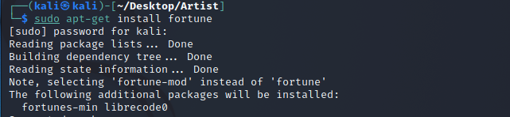

**Running GIMP**

